

RAFFLES INSTITUTION
PRELIMINARY EXAMINATION 2010

Higher 2

CANDIDATE
NAME

CLASS INDEX NUMBER

CHEMISTRY 9647/02

Paper 2 Structured Questions 20 September 2010
Planning
2 hours
Candidates answer on the Question Paper.

Additional Materials: Data Booklet

READ THESE INSTRUCTIONS FIRST

Write your name, class and index number in the spaces provided on the top of this page.
Write in dark blue or black pen in the spaces provided.
You may use a soft pencil for any diagrams, graphs or rough working.
Do not use staples, paper clips, highlighters, glue or correction fluid.

Answer all questions.
A Data Booklet is provided. Do not write anything on it.
You are reminded of the need for good English and clear presentation in your answers.

The number of marks is given in brackets [ ] at the end of each question or part question.

For Examiner’s Use

Question | 1 | 2 | 3 | 4 | 5 | 6 | 7 | Total
Marks | /12 | /14 | /5 | /4 | /20 | /8 | /9 | /72

This document consists of 17 printed pages
Answer all questions in the spaces provided.
For Examiner’s Use

1 In determining the molar gas constant, R, in the ideal gas equation, a student proposed the following reaction of barium sulfite with 0.50 mol dm^{–3} dilute hydrochloric acid.

BaSO₃(s) + 2HCl(aq) → BaCl₂(aq) + SO₂(g) + H₂O(l)

By collecting the sulfur dioxide gas and measuring its volume and other variables in the ideal gas equation, the molar gas constant, R, may be determined experimentally.

(a) Explain why dilute sulfuric acid should not be used.

……………………….....................................................................................................

……………………….....................................................................................................
[1]

(b) The student suggested collecting sulfur dioxide gas through the downward displacement of water. Suggest why this is not a suitable method.

……………………….....................................................................................................

……………………….....................................................................................................
[1]

(c) Draw a labelled diagram of the apparatus and the setup you would use to

- add the acid without loss of gas on mixing;
- collect and measure the volume of gas produced.

Your diagram should show how standard pieces of laboratory apparatus are assembled. You should also show clearly how these pieces of apparatus are connected together.

[3]
(d) What is the maximum mass of barium sulfite that should be used in the experiment to produce 100 cm³ of sulfur dioxide gas?
For Examiner’s Use
Assumptions:
- 1 mol of any gas occupies a volume of approximately 24 dm³ at room temperature and pressure.
- All gas produced is collected and measured in your experimental setup.

[1]

(e) List, in the order in which they will be made, the measurements you would take during the experiment.

You should
- ensure the completion of the reaction;
- make appropriate measurements of all the variables in the ideal gas equation.

……………………….....................................................................................................

……………………….....................................................................................................

……………………….....................................................................................................

……………………….....................................................................................................

……………………….....................................................................................................

……………………….....................................................................................................

……………………….....................................................................................................

……………………….....................................................................................................

……………………….....................................................................................................
[4]

(f) (i) Explain clearly why there is a discrepancy between the value of the molar gas constant obtained in this experiment with the theoretical value of 8.31 J K^{–1} mol^{–1}.
For Examiner’s Use

……………………….....................................................................................................

……………………….....................................................................................................

……………………….....................................................................................................

……………………….....................................................................................................

……………………….....................................................................................................

(ii) A teacher recommended the use of zinc metal instead of barium sulfite for this experiment. Suggest how this change could improve the accuracy of the experimental value of the molar gas constant, R.

……………………….....................................................................................................

……………………….....................................................................................................

……………………….....................................................................................................

……………………….....................................................................................................

……………………….....................................................................................................
[2]
[Total: 12]
2 The structure of methane, CH₄, and ethyne, C₂H₂, may be described in terms of the hybridisation of orbitals.
For Examiner’s Use
(a) State the type(s) of hybridisation present in the methane and ethyne molecules.

Methane: …………………………….

Ethyne: …………………………….
[2]

(b) Sketch the shapes of the hybrid orbitals around one carbon atom in the ethyne molecule.

[1]

(c) Methane is not acidic but ethyne (pK_{a} = 25) is a very weak acid. Ethyne reacts with strong base, sodium amide, NaNH₂ to form ammonia gas. Write the balanced equation for the reaction of ethyne with sodium amide.

[1]

Methane reacts with HF−SbF₅, a superacid to form an intermediate, [CH₅]⁺[SbF₆]⁻. The intermediate immediately decomposes to form [CH₃]⁺[SbF₆]⁻ and hydrogen gas.

CH₄ + HF-SbF₅ → [CH₅]⁺ [SbF₆]⁻ → [CH₃]⁺ [SbF₆]⁻ + H₂

(d) Use Brønsted-Lowry definition to describe how methane behaves as a base in this reaction.

……………………….....................................................................................................

……………………….....................................................................................................

……………………….....................................................................................................
[1]

(e) Explain why the intermediate formed is not stable.
For Examiner’s Use

……………………….....................................................................................................

……………………….....................................................................................................

……………………….....................................................................................................

……………………….....................................................................................................
[1]

(f) State the shapes and bond angles of [CH₃]⁺ and [SbF₆]⁻.
shape bond angle

[CH₃]⁺ ………………………..... ……………………….

[SbF₆]⁻ ………………................ ………………………..
[4]

2,2-Dimethylpropane reacts similarly with HF−SbF₅ to form an ionic salt with negative ion [SbF₆]⁻ and a gas A. The gas A contains 75 % of C by mass.

(g) Deduce the structural formulae of gas A and the positive ion of the salt.

Gas A:

Positive ion:

[4]
[Total: 14]
3 In 1999, researchers in Israel reported a new type of alkaline battery, called the “super-iron” battery. This battery uses the same anode reaction as an ordinary alkaline battery.
For Examiner’s Use
At the anode, Zn is oxidised to solid Zn(OH)₂, while the cathode involves the reduction of FeO₄²⁻ ion (from K₂FeO₄) to solid Fe(OH)₃.

(a) Suggest a reason why this battery is also called the “super oxidised iron” battery.

…………………………….…………………………….……………………………………..

…………………………….…………………………….……………………………………..
[1]

(b) Give the half-equations, with state symbols, for each electrode reaction in alkaline conditions.

Anode:

Cathode:

[2]

A “super-iron” battery should last longer than an ordinary alkaline battery of the same size and weight because its cathode can provide more charge per unit mass.

(c) Calculate the quantity of charge released by the reduction of 10.0 g of K₂FeO₄ to Fe(OH)₃.

[2]
[Total: 5]
4 A biochemist needs to prepare a CH₃COOH/CH₃COO⁻Na⁺ buffer solution to stimulate the growth of a particular fungus.
For Examiner’s Use
In order to investigate the composition of a CH₃COOH/CH₃COO⁻Na⁺ buffer solution of pH 4.16, the biochemist titrated 25.0 cm³ of this buffer solution with 1.0 mol dm⁻³ aqueous sodium hydroxide. The graph below shows the titration curve obtained.

X
X
Volume of
NaOH(aq) / cm³
pH_{equivalence}
pH

4.16

8x
3x

Upon the addition of 3x cm³ of aqueous sodium hydroxide, the buffer solution becomes most effective. The equivalence point of titration is attained when 8x cm³ of aqueous sodium hydroxide is added.

(a) Show that the ratio of [CH₃COOH] : [CH₃COO⁻Na⁺] is 4 : 1 in the original buffer solution.

[3]

(b) Determine the K_{a} of CH₃COOH.

[1]
[Total: 4]
5 Wang Daobo from Raffles Institution represented Singapore in the 2009 International Chemistry Olympiad held in Cambridge.
For Examiner’s Use
In the practical examination, he was asked to determine the formula of the negative ion of compound B, using two titrations. The negative ion of compound B is a complex ion containing copper, chlorine and oxygen.

The first titration was used to determine the proportion of copper ions in the complex. In this titration, the complex was reacted with EDTA solution. EDTA forms hexaco-ordinate complexes with copper(II) ions according to the equation:

Cu²⁺(from the complex) + EDTA⁴⁻(aq) → [CuEDTA]²⁻(aq)

(a) Complete the electronic configuration of copper(II) ions.

Cu²⁺ 1s² 2s² 2p⁶ ……………………………………………
[1]

(b) On the diagram below, circle the six atoms of EDTA that form bonds with the copper(II) ion.
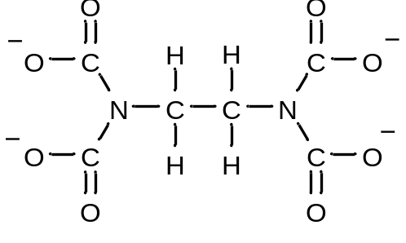
[1]

Daobo found that 0.100 g of B required 21.70 cm³ of 0.0200 mol dm⁻³ EDTA solution for complete reaction.

(c) Calculate the percentage by mass of copper in compound B.

[2]
The second titration determined the proportion of chloride ions in the complex. The chloride ions from the complex were titrated against 0.100 mol dm^{–3} silver(I) nitrate solution, and he found that 0.200 g of B required 21.70 cm³ of silver(I) nitrate using dichlorofluorescein indicator.
For Examiner’s Use

(d) (i) Give a balanced equation to represent the reaction in this titration.

(ii) Calculate the percentage by mass of chlorine in compound B.

[3]

Instead of using dichlorofluorescein indicator in this titration, a small quantity of aqueous potassium chromate(VI), K₂CrO₄, could also be used.

(e) Use the data given in the table below, state what you would see at the beginning of the titration and at the end-point.

 | colour | K_{sp} (at 25 °C)
AgCl | white | 2.02 x 10^{–10} mol² dm^{–6}
Ag₂CrO₄ | red | 3.01 x 10^{–12} mol³ dm^{–9}

Observations

at the beginning of the titration: ….………………………………………………………

at the end-point: ….………………………………………………………….....................
[2]

(f) At the end point, the concentration of CrO₄²⁻ is 0.01 mol dm⁻³. Show that Ag₂CrO₄ can only be precipitated when almost all AgCl has been formed.
For Examiner’s Use

[2]

The positive counter ion in compound B is the tetramethylammonium ion, (CH₃)₄N⁺.

The proportions by mass of carbon, hydrogen and nitrogen in compound B were determined by combustion analysis. The results were found to be C, 20.87 %; H, 5.17 %; and N, 5.96 %.

(g) With reference to your answers to (c) and (d) (ii), calculate the percentage by mass of oxygen in compound B.

[1]

(h) State which of the six elements in compound B has the greatest percentage error in the determination of its proportion?

…………………………….…………………………….……………………………………..
[1]
(i) The simplest whole number ratio of five of the six elements in B is presented in the table below.
For Examiner’s Use
 | Cu | Cl | C | H | N
Simplest  Ratio | 2 | 5 | 8 | 24 | 2

Determine the formula of the negative ion of B.

[2]

When NH₃(aq) is added to a solution containing Cu²⁺(aq), a light blue precipitate which is soluble in an excess of the reagent to form a dark blue solution is formed.

(j) Suggest an ionic equation for each of these two reactions.

[2]
With the addition of excess EDTA solution, the dark blue solution immediately turns to a light blue solution to form the hexaco-ordinate [CuEDTA]²⁻ complex according to the following equation:
For Examiner’s Use
[Cu(NH₃)₄]²⁺(aq) + EDTA⁴⁻(aq) → [CuEDTA]²⁻(aq) + 4NH₃(aq)

(k) Predict, with reasoning, the sign of ∆S for this reaction.

…………………….…………………………….……………………………………………

…………………….…………………………….……………………………………………

…………………………….…………………………….……………………………………

…………………………….…………………………….……………………………………

…………………………….…………………………….……………………………………
[2]

(l) The value of ∆H for this reaction is negative. Using this information, together with your answer to (k), explain why this reaction is always spontaneous.

…………………….…………………………….……………………………………………

…………………….…………………………….……………………………………………

…………………………….…………………………….…………………………………….

…………………….…………………………….……………………………………………

…………………….…………………………….……………………………………………
[1]
[Total: 20]
6 Commonly found in natural products, a lactone is a cyclic ester which can be formed when a molecule containing an alcohol group and a carboxylic acid group undergoes self-condensation.
For Examiner’s Use
A laboratory scientist attempted to synthesise a lactone starting from hydrocarbon C. His synthetic scheme is shown below.

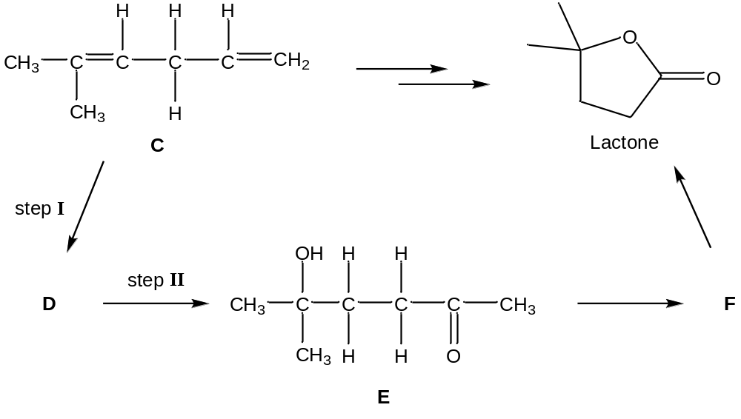

(a) (i) Suggest the reagents and conditions required for

step I: …………………….…………………………….…………………………………

step II: …………………….…………………………….…………………………………

(ii) Give the structural formulae of compounds D and F.

D
F

[4]

[4]
Compound G is a lactone derivatised with many functional groups.
For Examiner’s Use
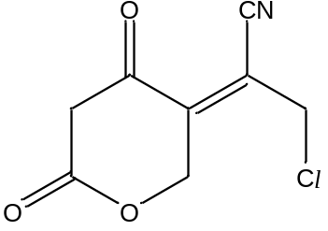

Compound G

(b) In the table below, draw the structures of all organic products formed when compound G reacts with

Reaction | Reagents and Conditions | Organic Product(s)
(i) | NaOH(aq), heat
(ii) | H₂(g) with Ni, heat
[4]
[Total: 8]
7 Tetramethylammonium iodide, [(CH₃)₄N]⁺I⁻, is a quaternary ammonium salt with four methyl groups covalently bonded to nitrogen. This salt can be prepared by successive alkylation of methylamine with excess iodomethane.
For Examiner’s Use

(a) Describe and explain why the basicity of methylamine, CH₃NH₂ differs from those of ammonia and dimethylamine, (CH₃)₂NH.

…………………………….…………………………….……………………………………..

…………………………….…………………………….……………………………………..

…………………………….…………………………….……………………………………..

…………………………….…………………………….……………………………………..

…………………………….…………………………….……………………………………..

…………………………….…………………………….……………………………………..
[2]

Trimethylpropylammonium iodide can also be prepared by alkylation of methylamine.

(b) Suggest the structural formulae of compounds P and Q in the following scheme:

P
Q

[2]

Trimethylpropylammonium iodide is heated with moist silver(I) oxide to form a quaternary ammonium hydroxide, which reacts further to produce propene and trimethylamine.
For Examiner’s Use
heat
[(CH₃)₃NCH₂CH₂CH₃]⁺OH⁻ ⎯⎯→ CH₂=CHCH₃ + (CH₃)₃N + H₂O

(c) (i) What type of reaction is occurring here?

…………………………….…………………………….……………………………………..

(ii) Draw the structural formulae of the three products, R, S and T formed in the following reactions:

R

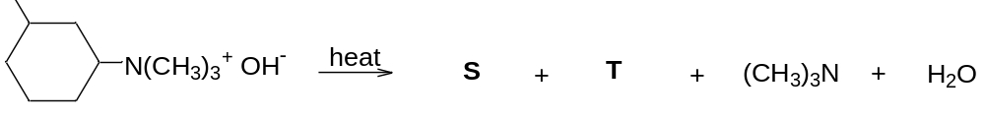
or

S
T

[5]
[Total: 9]

END OF PAPER

